WEST LONDON WASTE AUTHORITY
3rd December 2021
Circular Economy and Net Zero Carbon update
SUMMARY
This report provides an update on the partnership activities to progress circular economy, net-zero carbon and climate emergency projects.
RECOMMENDATION(S)

The Authority is asked to
- Adopt the Circular Economy Strategy in appendix A
- Note the information within this report and appendices B and C

- Introduction - West London Waste has been working in partnership with the six constituent boroughs and wider sub-regional groups to advance our common aspiration to help build an effective response to the climate emergency and net-zero carbon targets as well as striving to create a circular economy. This report provides high-level updates from the key programmes of work.
- WLWA Circular Economy Strategy & Principles – The Authority is asked to adopt WLWA’s Circular Economy Strategy in appendix A. It incorporates waste disposal policies (principles) expanding on our vision and actions being taken. There are four key principles to guide us to design, plan and prioritise our projects:
- give resources away to stimulate the growth of the reuse and repair markets and drive innovation;
- create a circular economy hub in each WLWA Borough, over the period of the Circular Economy Strategy;
- focus on high impact materials such as food waste, textiles and e-waste; and,
- actively engage and collaborate with the public, private and third sectors to foster and instigate innovative solutions.
- WLWA Circular Economy Activities
  - Circular economy hubs – discussions with LB Ealing are continuing regarding the potential opportunity to use the Acton HRRC site to create a thriving community resource built on circular economy principles. WLWA is exploring collaborating with local community groups to increase food recirculation and local food production. Suez has proposed to install a small-scale circular economy hub at our Victoria Road Transfer Station this financial year.
  - Abbey Road Resource Rescue (for Reuse/Repair)
    - The Abbey Road team won the Team of the Year at this year's LGC (Local Government Chronicle) awards, the most prestigious for the UK local government. The award submission focused on the site's transformation away from a waste site to one that treats items as valuable resources.
    - 20 bicycles collected at Abbey Road have been repaired and given to 2 local schools, in Brent and Ealing. A partnership is being built with Feltham Young Offenders Institute to repair collected bicycles as part of their rehabilitation programme and support local communities.
    - Over 1 tonne of wooden furniture, 50 items, has been sent to charitable social enterprise Petit Miracles, they give people a chance to become their best selves through employment training. Abbey Road colleagues visited their workspace and shop to see what happens to the items being separated at site.
    - The Restart Project have secured funding from the National Lottery Climate Action Fund to set up a Fixing Factory at Abbey Road. Local volunteers and professional repairers will repurpose computers brought into HRRCs and provide training and working experience to young people. Refurbished computers will be given to local schools and community groups.
    - PCs and laptops continue to be collected for Hubbub’s repair, refurbish and re-distribution scheme.
    - Items for children under 5 are being collected for Little Village Baby Bank in Brent. 12 pushchairs/prams have been sent in the last 2 months.

- WL Climate Emergency Officers Group – A collaboration between 9 west of London Boroughs, sharing ideas and resources, joint working to ensure collaboration, and ensure consistency in measures and messages between boroughs.
  - CEOG Action Plan Revision – Following the revision of WLA’s Build & Recover Plan the CEOG revised its action plan. The new plan consists of three pillars: Green Infrastructure, Green Communities and Green Skills (detailed in appendix B). Transportation and Energy, and Infrastructure were also added to the action plan. Each borough is leading on an area within the plan.
  - Low Carbon Procurement – a charter, policy and toolkit are being developed to assist boroughs to integrated net-zero carbon and circular economy principles into their procurement processes. The final products will be published by the end of 2021 and adopted by west London local authorities. This work stream has been led by Harrow Council supported by a working group consists of procurement leads from eight boroughs and WLWA.
  - Circular Economy – WLWA led workshops to develop thinking on this area. The lead officer from Wandsworth and Richmond Council was involved in these initial workshops and has now established a working group to build west London wide policy and toolkits for the Boroughs to adopt. WLWA are continuing to work in this group on visions, priorities and action plans for west London.
  - Low Carbon Planning – There are many aspects of circular economy and low carbon solutions and infrastructure that require planning expertise. WLWA has been working with WLA and is proposing to host a jointly funded role to support both organisations increasing infrastructure development such as treatment (repair, upcycling etc.) sites and heat networks through joint planning policy development.
  - Energy Infrastructure / WL Energy Managers Group – Hillingdon is leading on the new action plan area of energy infrastructure. Close links have now been established with the West London Energy Managers group, set up by Hounslow. WLWA has also been involved in practical discussions exploring carbon reduction opportunities.
  - Restart Electrical Repair Directory – The proposal is for a web-based directory to help residents find reliable repair businesses in their local area for electrical items. It is currently utilised well in North and East London. WLWA is coordinating this work for the west London boroughs to reduce costs to boroughs. Mapping of local businesses will be completed by the end of this financial year.
  - Public Engagement, COP26 – WLWA offered support and resources to the boroughs to run their COP26 events. We deliver recycling/food waste talks and an information stand to residents and schools at events in Richmond and Hounslow. WLWA has also promoted borough events via its social media platforms.
- LEDNet Programme: One World Living (Reducing Consumption-based Emissions) – This is one of the key seven themes set up by LEDNet/Transport and Environment Committee (TEC), led by Harrow. WLWA has been closely working with Harrow, providing programme support. The programme focuses on key four areas: Food, textiles, electronics and plastics, each theme has lead authority(ies). The overall action plan will be presented to TEC in December, appendix C summarises the approach. These are vital programmes to drive the changes needed in London.
  - Steering group & Action Plans – WLWA is co-lead with Wandsworth on the textile theme, utilising our experience and industry knowledge to develop this material program because of its high carbon impact.
  - Waste Disposal Authorities – to create a wider and collaborative network of key players for the programme, WLWA has reached out to other WDAs in London and secured their involvement in this programme. This will provide a useful platform to share knowledge/information, experience and expertise among WDAs.
  - Data – data capturing and sharing is crucial for the programme, and WLWA will proactively engage and share data/information such as waste composition analysis with the programme members. The learning will also be extended to internal colleagues to incorporate available information into our project planning and prioritising.

Contact Officers | Peter Tilston, Projects Director | 07796 271 713
 | petertilston@westlondonwaste.gov.uk
 | Motoko Doolan, Net Zero Carbon Manager | 07917 075 876
 | MotokoDoolan@westlondonwaste.gov.uk
 | Mildred Jeakins, Circular Economy Manager | 0781 770 1134
 | mildredjeakins@westlondonwaste.gov.uk
 | Sarah Ellis, Project Team Leader | 07584 631 710
 | SarahEllis@westlondonwaste.gov.uk

Appendix A

Circular Economy Strategy December 2021

WLWA has a unique and key role in enabling and facilitating changes to keep materials circulating for longer whilst maximising their value by acting as a ‘resource transformation body’ rather than simply a waste disposal authority. This is a transformational strategy that seeks innovation and creativity in managing our resources. WLWA will work closely with our borough partners to embed circular economy principles into our operations and procurement activities. Businesses, charities and residents will be supported to reduce resource consumption whilst increasing material circularity. WLWA will influence circular economy changes at national and international levels.

Mission
Close the loop between waste and resources.

Context
In a circular economy resources are kept in use for as long as possible to retain their value. Waste is designed out to reduce reliance on raw, virgin and often imported materials in order to promote resource efficiency.

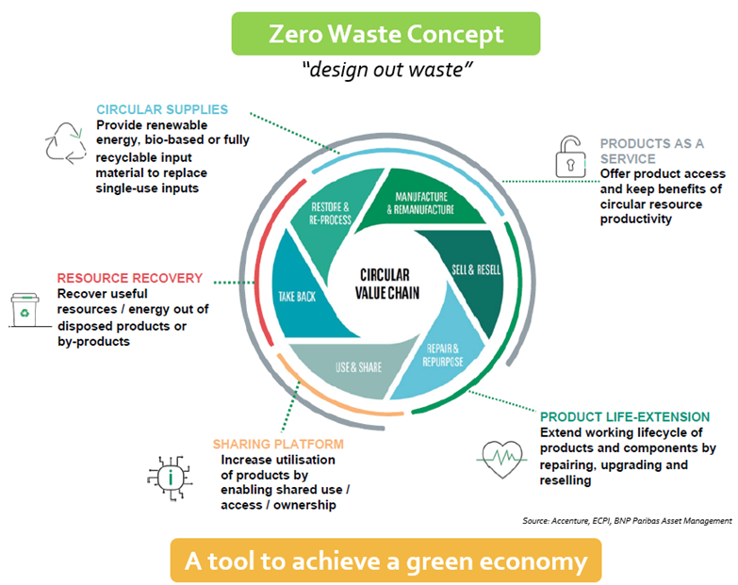
The current linear economy which ‘takes, makes, and disposes’ is inherently unsustainable as resources are only finite. The UK Resource and Waste Sector Plan estimates the transformation to a circular economy will provide up to £9 billion gross value added benefit and more than 40 million tonnes of CO²e savings. It also suggests that every £1 invested will bring more than £2.40 of social value.

- Strategic links with other priorities
This strategy links with the following areas and existing strategic documents.

Joint Municipal Waste Management Strategy / WLWA Five-Year Programme: These key documents map out WLWA’s priorities and direction. They reflect the significant changes resulting from recently adopted legislation and strategies including the Environment Act, The Resource and Waste Strategy and the London Environment Strategy.

Climate Emergency / Carbon Targets: All six constituent Boroughs declared a ‘climate emergency’ in 2019 and pledged to become carbon neutral by 2030. There are plans in place and being developed to drive this forward in west London. Circular economy principles are vital in transforming west London into a net-zero community.

A Green Recovery, Green Skills and Jobs: A circular economy is widely seen as a step towards achieving a green economy. A circular economy requires new technologies, innovation, and additional infrastructure to treat our resources. The London Recovery Programme, in particular a New Green Deal, the LEDNet Building the Green Economy programme and WLA’s Build and Recover Plan provide a framework and priorities for the region for WLWA to link with.

Principles
Since the circular economy programme involves new, innovative and untested projects an agile approach is needed. Whilst focusing on a big vision, being flexible, responsive and adaptive to make sure we are implementing practical solutions and improvements that suit local circumstances is a priority. These four key principles will provide guidance to design, plan, and prioritise our projects. WLWA will:
- give resources away to stimulate the growth of reuse and repair markets and drive innovation;
- create a circular economy hub in each WLWA Borough, over the period of the Circular Economy Strategy;
- focus on high impact materials such as food waste, textiles and e-waste; and,
- actively engage and collaborate with the public, private and third sectors to foster and instigate innovative solutions.

Key Actions & Milestones
Short-term actions (1-2 years)
- Develop reliable and accurate data about materials, behaviours and waste composition to support targeted development of material action plans.
- Influencing/lobbying government and producers for circular solutions, wider than Extended Producer Responsibility.
- Community/stakeholder mapping to identify local opportunities to enact change.
- The delivery of two Circular Economy Hubs and appropriate circular economy infrastructure, e.g. a sharing platform.
- Develop consistent services to facilitate circularity, such as bulky item reuse.
- Embed sustainable circularity into local authority procurement and services.
- Develop a tool to measure social value/benefits.
- Engage and communicate widely.

Mid-term actions (3-5 years)
- Further planning and investment in additional circular economy infrastructure such as Hubs and community centres.
- Creation of training opportunities for green skills to develop the circular economy.
- Development of education and communication activities appropriate to the stage of circular economy development.

Long-term actions (6+ years)
- Developing local resource management to enhance local neighbourhoods and communities.
- A robust west London self-sufficiency tool in place to measure the benefits.

Key Indicators
Each project will have a set of indicators to determine progress and success, these will fall within the scope of these four areas:

- Social benefits - local job creation and green skills development that will support the overall Green Recovery; supporting vulnerable people and disadvantaged communities to achieve fair and reasonable access to transport, space, food and products/services.
- Environmental benefits - linking directly with sustainable resource management including carbon reductions, whole-life costings and renewable energy consumption.
- Self-sufficiency of raw materials – achieving maximum value locally and ability to circulate back to their original intended state without dependencies on virgin materials and markets.
- CE/Green investments - £ invested in circular/green economy activities.

- Stakeholder Engagement

A circular economy cannot be achieved by one organisation. By understanding and engaging with a wide and representative platform of public, private and third sector stakeholders, an opportunity to co-innovate and understand the roadblocks to circular economy transformation will be created. Ultimately this will facilitate systemic change at the desired scale.

Developing and utilising positive communication and relationships will expedite circular activities. For example when infrastructure is ready to be constructed and be used, there would be actively engaged partners ready to take action immediately.

Diagram below illustrates the type of stakeholders to engage with to put in place the principles and reality of a circular economy.
Public Sector Partners
- Disposal authorities
- Collection authorities
- Procurement and financial teams
Green Skills/ knowledge
- General public
- Businesses
- Education Sectors
- Politicians
Private Sector Partners
- Waste management companies
- Reprocessors
- Take-back and compliance scheme operators
Policy/Legislation
- Central & regional governments
- Academia
- Boroughs
Product Designers
- Producers / Manufacturers
- Academia
WLWA Circular Economy

- Future of Materials

Society needs to rethink the way materials are treated. WLWA will build a vision for the different materials discarded in west London and identify practical solutions to improve their circularity.. It is anticipated that as new technology and innovations become available and new policy measures are in place, different solutions and treatment routes will become possible. WLWA will continue to be agile and responsive to changes to be able to support innovations and demonstrate leadership.

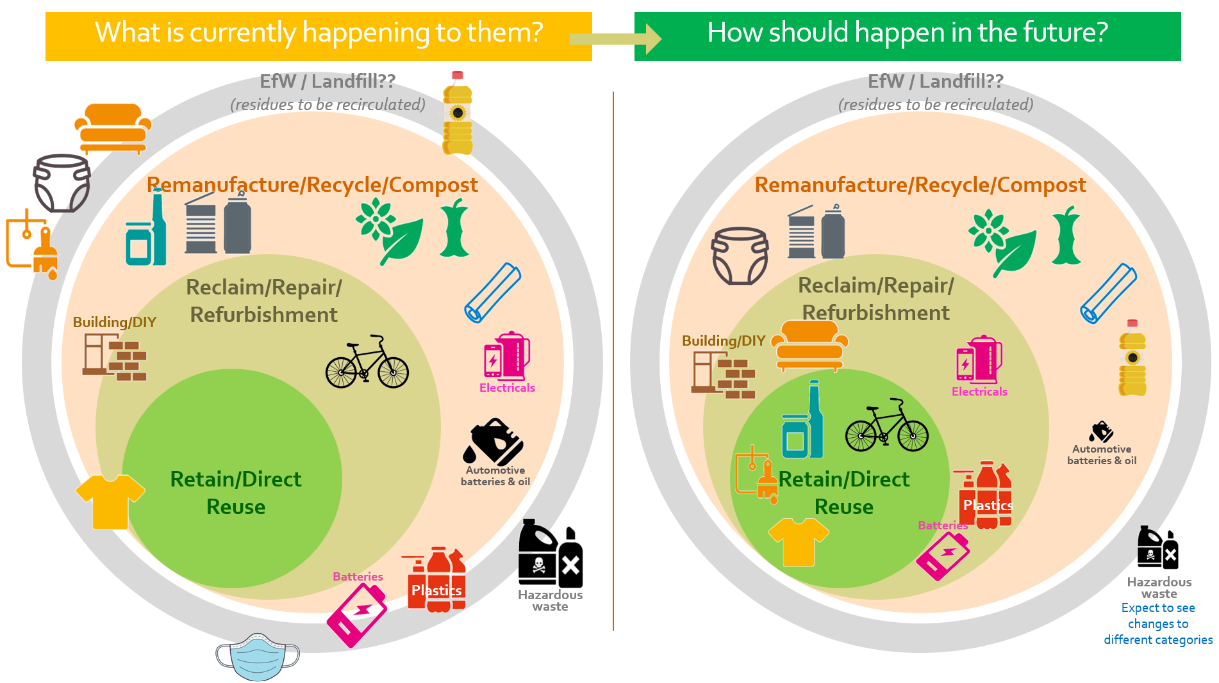

Appendix B – WL Climate Emergency Officers Group Action Plan

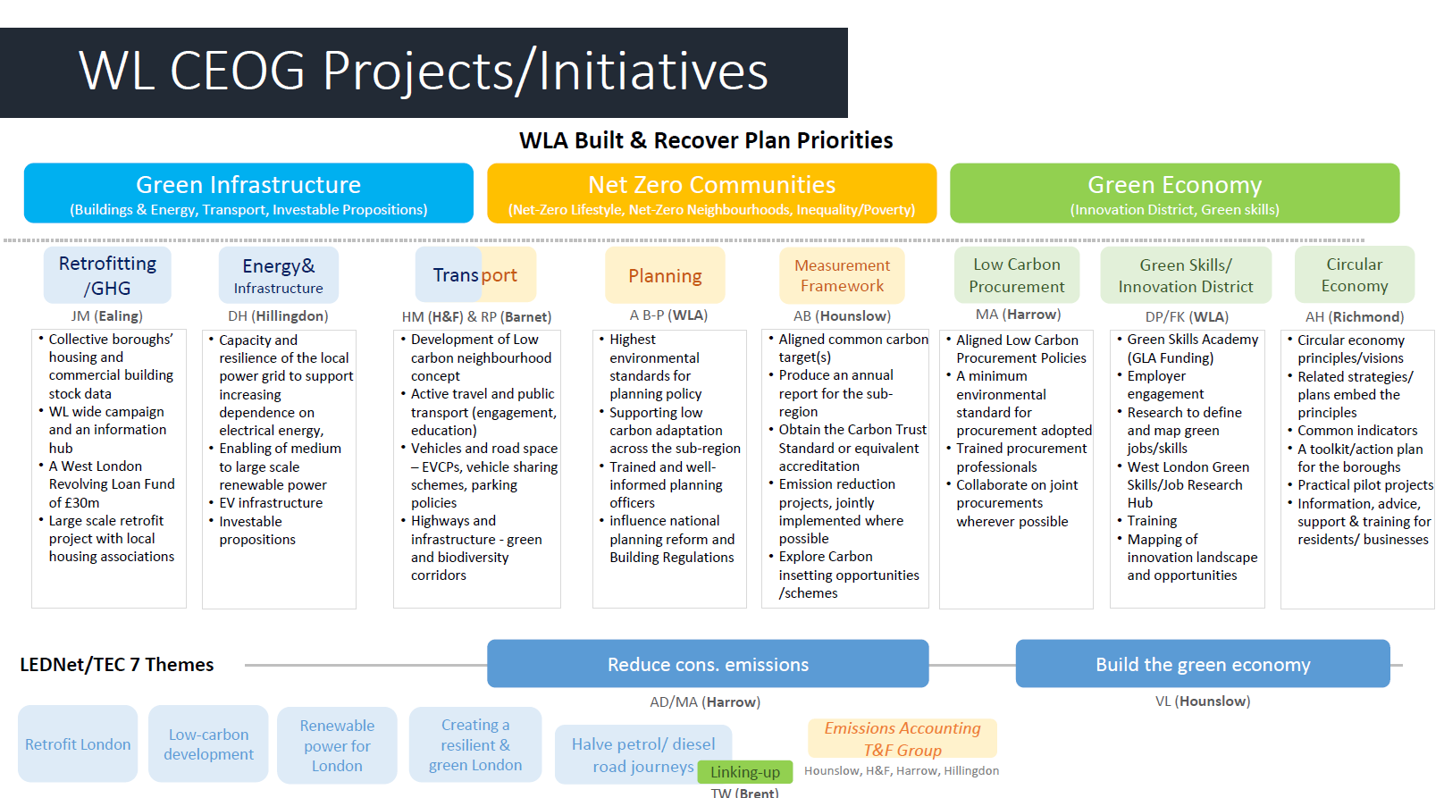

Appendix C – OWL Programme Approach

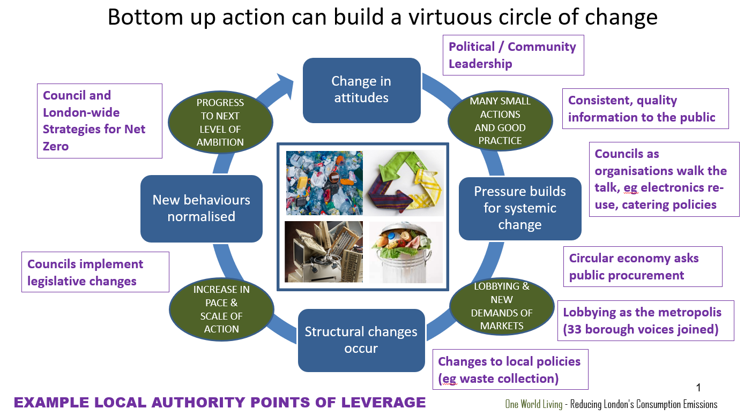

Appendix C – OWL Programme Approach (cont.)

